Deploying a VM from a Custom Image
Problem Statement: Create a custom image and deploy a VM from it
Step 1: Go to the virtual machine for which you want to create a VM. Click on ‘Capture’ in the top menu bar
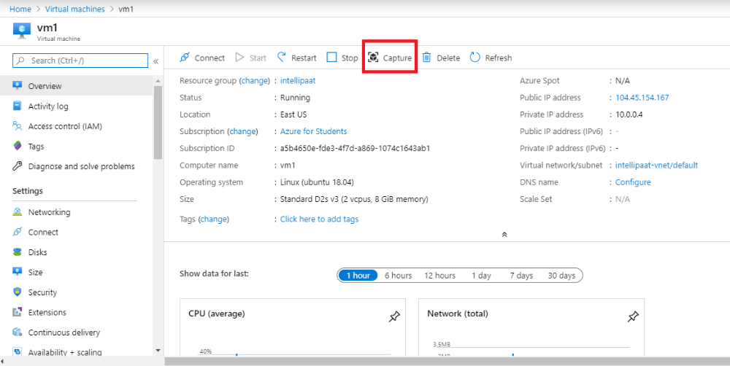

Step 2: Fill in the details as required and click on ‘Create’
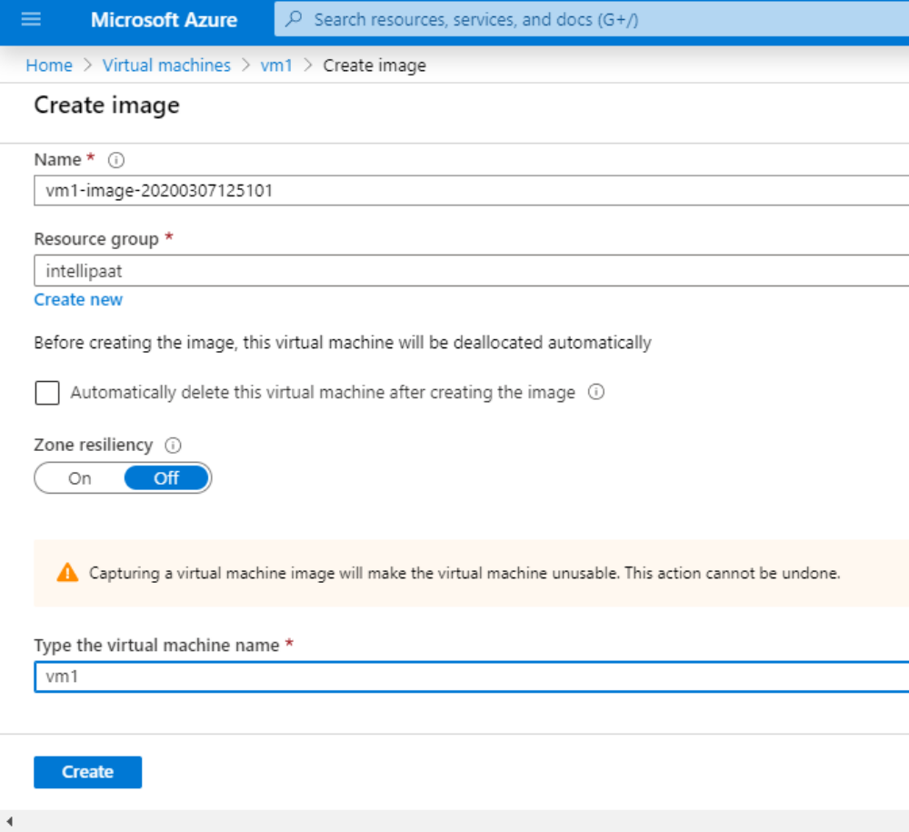
Step 3: Once the deployment is complete, go to the resource and click on ‘Create VM’
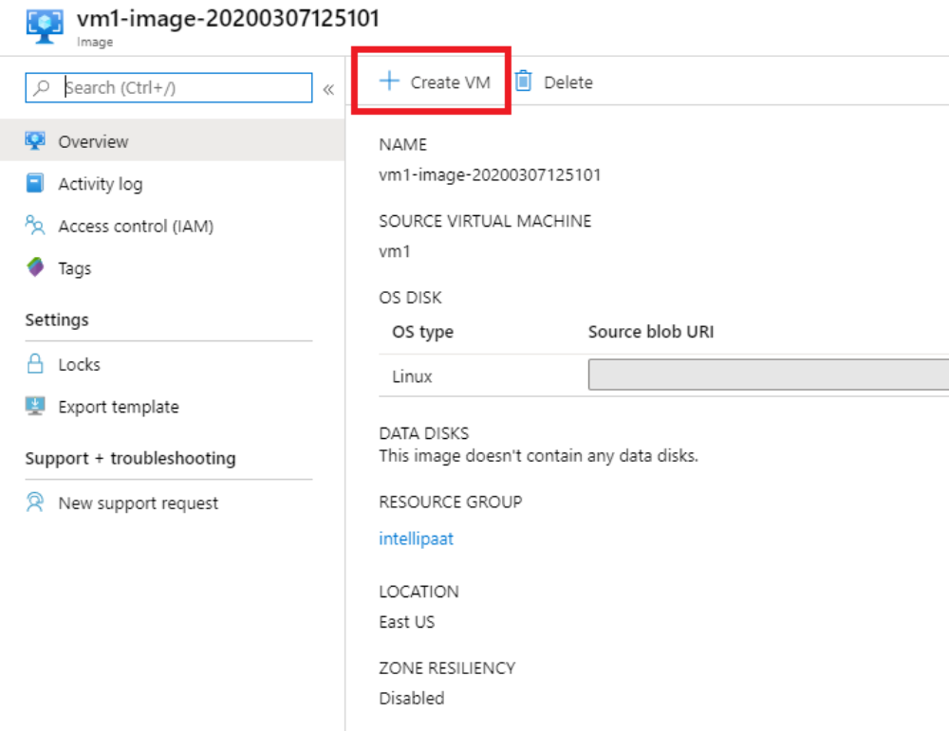

Step 4: It will redirect you to a wizard for creating a virtual machine. Fill in the name and resource group as required. Then, click on ‘Review + create’
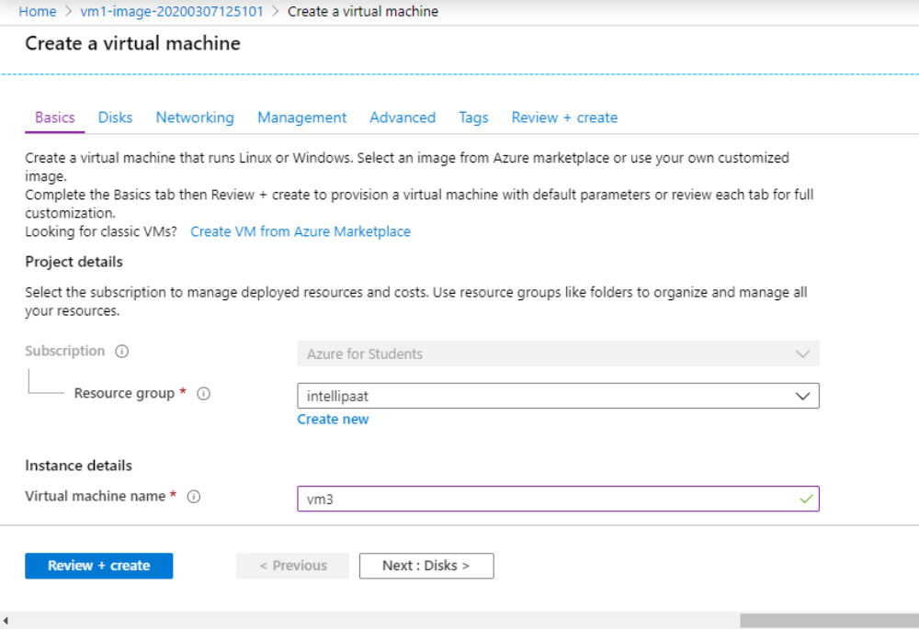
Step 5: Once the deployment is complete, you can check the list of virtual machines. You’ll see your VM with the source as ‘Image’
